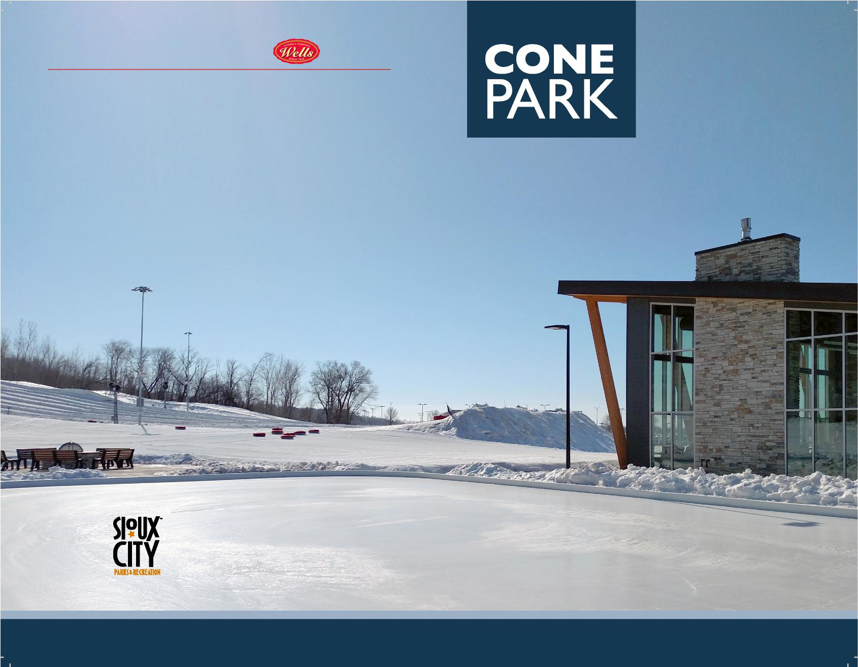

**LODGE CONTENTS provided by**

**Cone Park has a seasonal concession stand/warming lodge to make your visit comfortable and enjoyable!**

**Concessions**

Hot Cocoa

Coffee

Beer

Wine

Food/Snacks

NON-PROFIT

FUNDRAISING

**Amenities**

Free WiFi provided by Long Lines

Free Parking

2 Mile Trail Loop

Free Splash Pad ***(Summer)***

**Sioux City Parks and Recreation**

**Cone Park**

**3800 Line Drive**

**Sioux City, IA 51106**

**712-222-CONE or 712-279-6126**

**Monday - Thursday**

6:00pm - 9:00pm

$1,000.00 per 3 hour session

*Ice skating included with admission; ice skate rentals not included in fee.*

**Want to potentially make more money for your organization? Rent the session for $1,000 and you have exclusive use of the park. Select the rate you charge patrons. Whether you charge $5 or $8 you are making a profit with a sell-out crowd!**

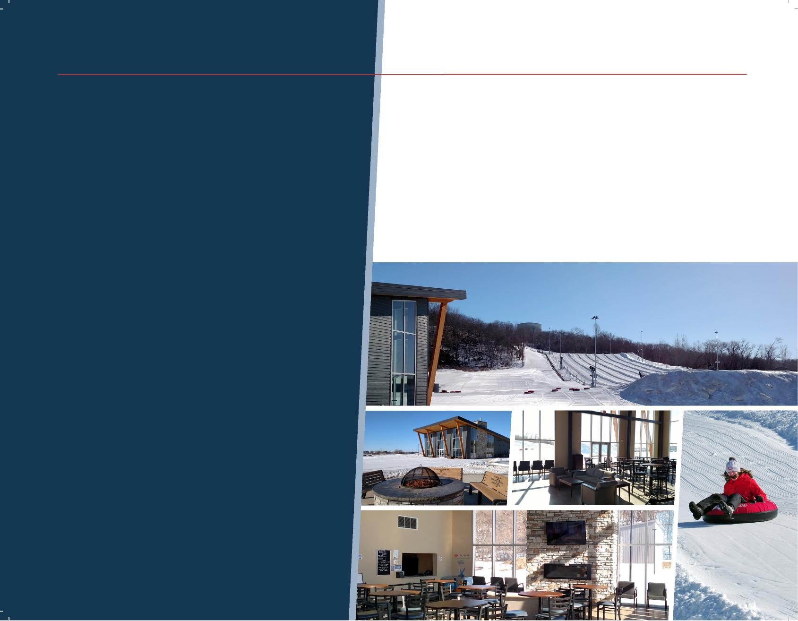

**OPTION 2**

**OPTION 1**

**Are you an organization who wants to have a great event for your patrons, pay no money up front, and receive money in return? A Cone Park Fundraiser is for you!**

**AVAILABLE DAYS & HOURS**

**Monday - Thursday**

6:00pm - 9:00pm

$7.00 per person *(3 hour session)*

*Ice skating included with admission; ice skate rentals not*

*included in fee.*

**FUNDRAISING REBATE SCALE**

* **$1.00** will be returned for every admission up to 150 *(minimum 50)*.
* **$2.00** will be returned for every admission up to and over 151 *(maximum 225).*
* **$450** maximum return.

To select your fundraising date contact:

**John Byrnes**

402-680-4790

[jbyrnes@sioux-city.org](mailto:jbyrnes@sioux-city.org)